Understanding Even and Odd Signals | Signal Processing Basics

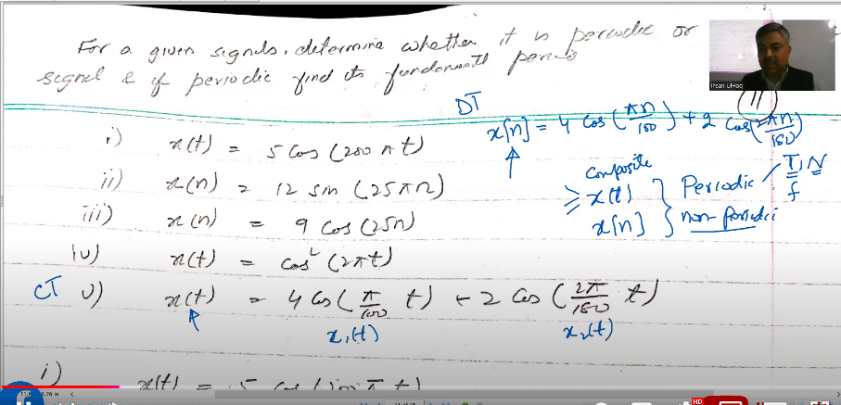

Past paper 2022 DSP

Question no 1:

Question 1:

1) What is quantization, and, quantization error? How is quantization error e(t) related with the step size A in case of rounding and truncation? How is quantization step size A related to number of quantization levels 'L' and number of bits 'b'?

(3 Marks)

2) Let a discrete-time signal x[n] = 2.1sine (n+1) +1 is quantized with step sizes (a) A=0.05, and (b) A= 0.01. How many bits are required in A/D converter in each case? Among the two cases which quantization is more accurate?

Question no :02

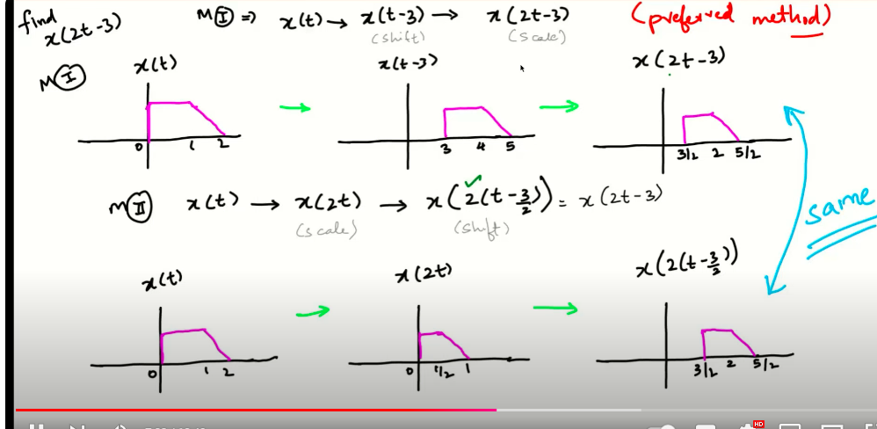

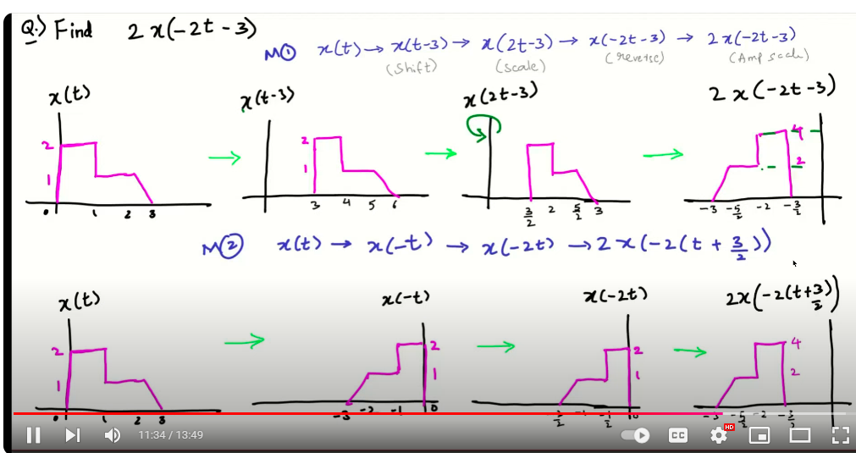

Question 3:

(CLO_2)

1) Signal x[n] is passed through the system with impulse response h[n] given below. Determine the response y[n],

(4+1 Marks)

1 2 0, (n², h[n] = 10, x[n] = -1≤n≤3 otherwise -1≤n≤1 otherwise Is the system given by h[n] an FIR or IIR, and why? Is h[n] a stable system or unstable system, and why? and

2) Find the natural response of the following LTI system with given initial condition. (2 Mark)

2 1 2y[n]-zy[n-1]=x[n] + 3x[n-1] y[0] = 2 (+) 3

3) Find the z-transform of the following signals using the definition of z-transform and find their region of convergence?

(3 Marks)

a) x[n] given in Figure-1.

b) x[n] = ()u[n - 2]